User Stories

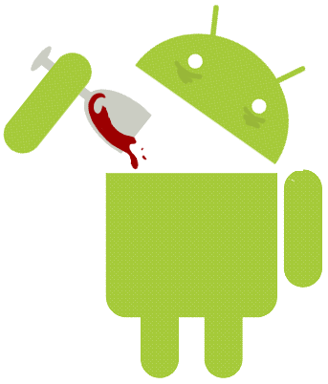



SHARON CHUNG
SAM FORMATO
BRIAN TAI
NAY TUN
ARASH VATANPOOR
CHRIS WELLER
WILLIAM WERNER
ZHIHUI XIA
JESSE ANGELO YEH
ZHAOYANG ZENG

TABLE OF CONTENTS
US1 – Profile Creation | 5
US2– Account Login | 5
US3 – View/Edit Profile | 5
US4 – Choose a Wine | 5
US5– Wine Profile | 5
US6 – Choose a Wine | 5
US7 – Input Wine Intake | 5
US8 – Change Glass Size | 6
US9 – Wine Profile | 6
US10 – View Wine Notes | 6
US11 – Edit Wines Notes | 6
US12 – View Wine Information | 6
DUC13 – Display Tagging Info | 6
DUC14 – Create New Tags | 6

Design User Stories

1. As a user, I want to be able to create an account in the application, so I can login to the system using this created account.
2. As a user, I want to be able to login to the system with the account that I created so I can get the most out of the application.
3. As a user, I want to be able to go to my profile to view and edit my personal info, and get useful information regarding my activities in the application.
4. As a user, I want to be able to search a wine based on its name, type or tag so that I can read information about it, add my personal experience with the wine, input the amount of the wine I consumed, and view other people’s comments about it
5. As a user, I want to be able to go to specific wine profile that I selected, so that I can learn more about the wine, read other people’s comments, add comments about my experience,, create tag for the wine, and save it as my favorite.
6. As a user, I want to be able to record how much of a particular wine I have drunk, or currently drinking, so that I can track my wine consumption, view my blood alcohol level, and know approximately when It will be safe to drive.
7. As a user, I want to be able to enter a wine name, and see what particular food or food type is a good match to accompany the wine. Also I want be able to input a food name or type, and see what are the good wine matches for this specific food.
8. As a user, I want to be able to get wine recommendation from the system by giving basic information to the system about the properties of a wine, or just the flavors that I like. For example, if I ask the system to recommend me a wine that has low-alcohol content, is sweet, and has peachy taste, the system should recommend me at least one wine name that has these characteristics, for instance Moscato wine.
9. As a user, I want to create different tags for the wine based on my experiences and have the application record those tags and display them in a useful manner.
10. As a user, I want to be able to view what wines I have consumed, on what date, and how much of that wine I consumed. I would also like to be able to sort wines drank by date drank, vintage, amount drank, etc.
11.As a user, I want to be able to go home after a day of wine tasting at a winery and check my wine tasting information on the website and be able to look at the information I didn’t have time to look at while wine tasting.
12. As a user, I want to be able to use tags to build a wine if I am indecisive of choosing a specific wine.
13. As a user, i want to be able to select which function of the app I am using by navigating an easy to use selection screen. I would also like to be able to designate which function will default as my home screen (after logging in).

